**EVOLUTION OF COVID-19 AND CURRENT STATE OF THE ECONOMY**

**IN THE STUDY CITIES OF LATIN AMERICA**

**Santa Cruz**

At the beginning of the Covid-19 pandemic, the canceling of flights and entry of people to Galapagos allowed the islands to avoid community contagion for a time. However, with the to the reactivation of tourism, the main driver of the local economy, Covid-19 cases increased in the Islands.

The entry of tourists, generated the return of a large number of human resources from the continental territory, causing crowding of people on festive dates and the falsification of RT-PCR tests, which is stressingthe Local Health System.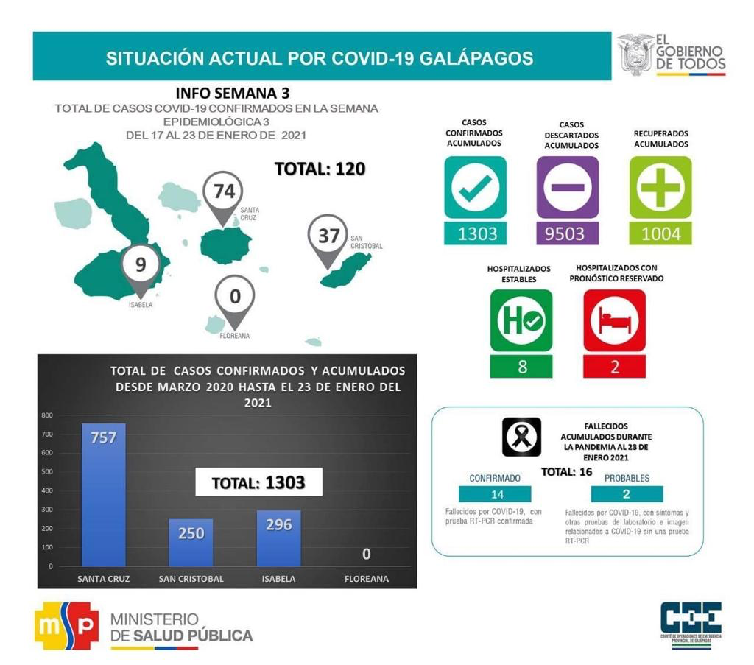

After the start of the new year, the reactivation of the private tourism companies is expected tosupport the local economy, which is in a critical state. For their part, the local and national government continue to support those who have been affected by the loss of their jobs and businesses with vouchers and food kits,

As part of this reactivation, the first vaccination pilot against Covid-19 has also started, andn February 1, 222 doses of Anti Covid-19 vaccinesarrived to Galapagos. The Ministry of Health will administer this first pilot phase, and front-line health officials from the three most populated islands will be prioritized, as well as the elderly. This pilot plan is scheduled to administer a total of 222 doses in its first phase.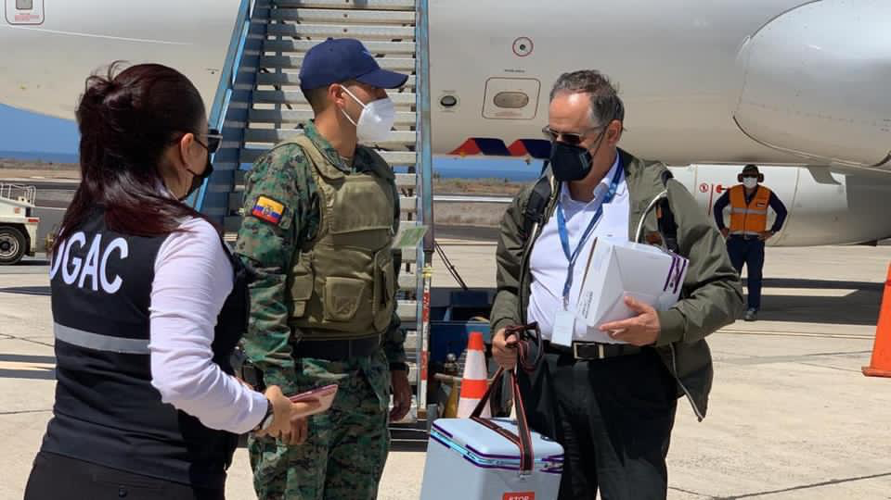

**Ouro Preto – Brazil**

As in other parts of the world, local governments in Brazil took several actionsagainst the spread of the COVID-19 pandemic. In the case of the municipality of Ouro Preto, two of the main non-pharmacological policies closedeconomic activities and encouraged social distancing. These policies achieved the deceleration of contagion by mid-2020, avoiding a much worse scenario (see cumulative cases in Figure 1).

Figure 1

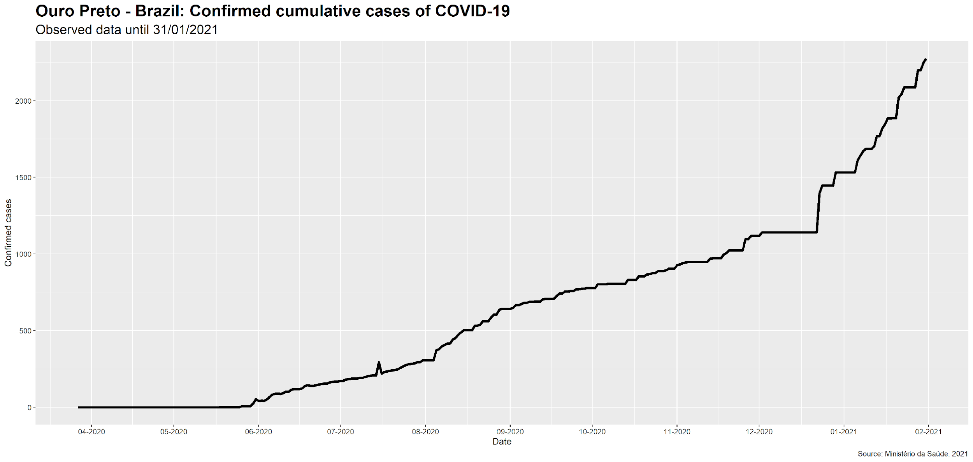

However, closing economic activities caused several important economic impacts in Ouro Preto, including unemployment, lower circulation of tourists, and smaller municipal income. Employment losses, including in the tourism sector, were significant even in the initial stages of the pandemic, during the first semester of 2020 (Figure 2).

Figure 2

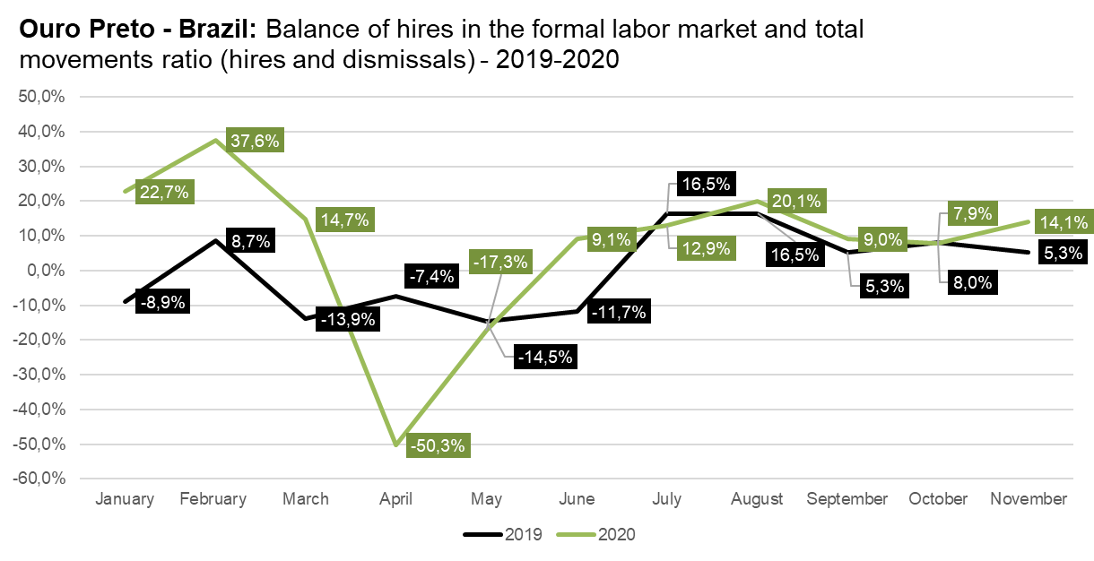

Source: Ministério da Economia, 2020

While epidemiological indicators showed stability and even reduction in the number of cases, pressure from the population and economic sectors led the municipality to reopen local business. As a consequence, incidence rates have risen and reached a critical level.

Figure 3

Adjustments between non-pharmacological actions, lockdown/social distancing policies, and retaking economic activities and services (such as reopening schools and colleges), are the main policy challenge in Ouro Preto in 2021. The municipality is also aiming tocreate, in cooperation with state and federal governments, an economic recovery and a vaccination plan targeting the whole municipal population -- these tasks are particularly challenging in a short term scenario, when the number of cases is expected to grow 64.4% on average, between 1st January and 1st April, 2021 (Figure 4).

**Cusco**

The first case of COVID-19, reported in Peru was on March 5, 2020. In the Cusco Region, the first case of COVID-19 was reported on March 13 that same year. According to DIRESA*, up until December 31, 2020, there were 77,724 confirmed cases and 1,319 deaths in the region, and the province of Cusco, the capital of the region, registeredthe largest number of cases (50,221) and deaths (809).

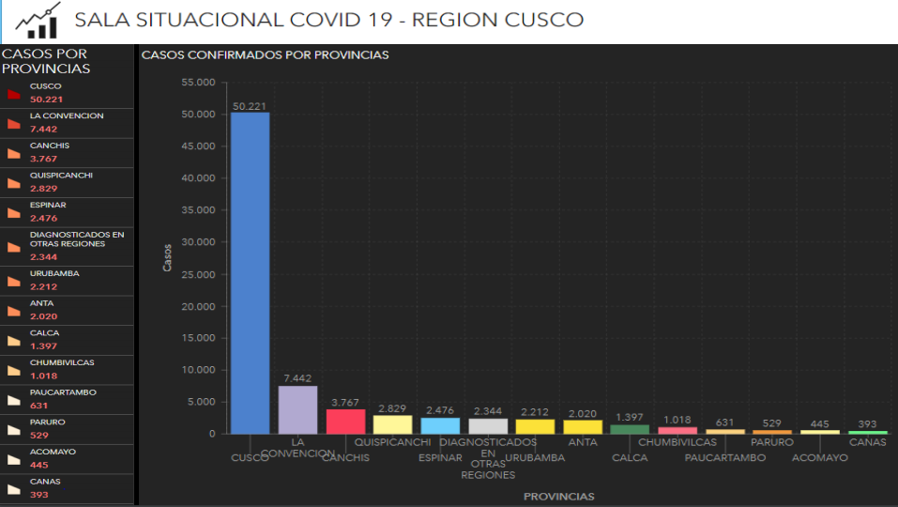

Source: Cusco Regional Direction (Dirección Regional de Cusco) – DIRESA CUSCO

What began as a 15-day quarantine lastedfor several months, andrestricting the exit of vulnerable population groups (children, pregnant women, and older adults), enforcing movement restrictions and a curfew, enforcing a curfew on the movement of people and vehicles, and further restricting movement outside of the house by assigning approved days to different genders. It was also mandatory, as an individual protection measure, to wear a mask - chinstraps, face shields (for use in public transport), and social distancing (from 1m to 1.5m apart). Social gatherings were prohibited, and shops, educational institutions centers and religious worship centers were closed. At the peak of restrictions, borders were closed and interprovincial transport banned. Essential activities, such as sale of necessities (food), pharmacies, hospitals (emergency and COVID-19 cases), public cleaning, banks and the like (banking agents, cooperative banks) were authorized to operate.

The most affected sectors were transportation, commerce, tourism and education, with the Cusco economy contracting by 18.5%, restricting tourist activity 100% ** in the first half of 2020.

Remote activity was the most widely used viable outlet in education and other office jobs, as well as the increase in home delivery activity. Many businesses had to adapt to this type of sales. The State, as a measure of economic activation, provided different types of subsidies ***; which allowed economic activities to implement biosecurity protocols, which included the reduction of building capacity, until reaching semi-face-to-face work activity AFP and CTS).

* <http://www.diresacusco.gob.pe/salacovid19/SS_COVID-19_DC_311220.pdf>

** <https://cdn.www.gob.pe/uploads/document/file/1320682/Reporte%20Regional%20de%20Turismo%20-%20Cusco%202020.pdf>

*** <https://www.gob.pe/8895-coronavirus-apoyos-economicos-del-estado-por-el-aislamiento-social-obligatorio>

**Santiago de Chile**

The first cases of COVID-19 in Chile appeared in the first weeks of March 2020. The epidemic reached its peak in mid-June, with a reduction in the average daily cases from there, up until December.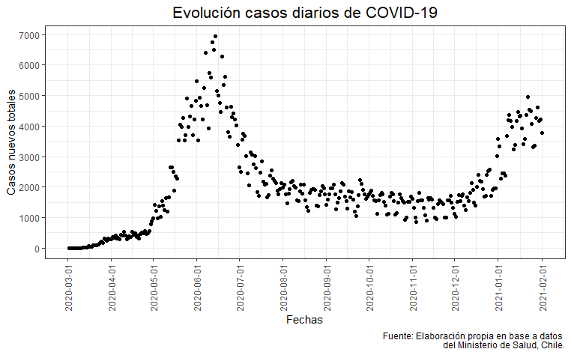

As of December, Chile begins its second wave of infections, which is still ongoing. In total, as of January 31, 2021,, the country has registered 723,000 positive cases, as well as 18,339 official deaths from COVID-19. The pandemic has generated an unprecedented economic crisis in the country and only comparable in its consequences to that of the crisis in 1982.

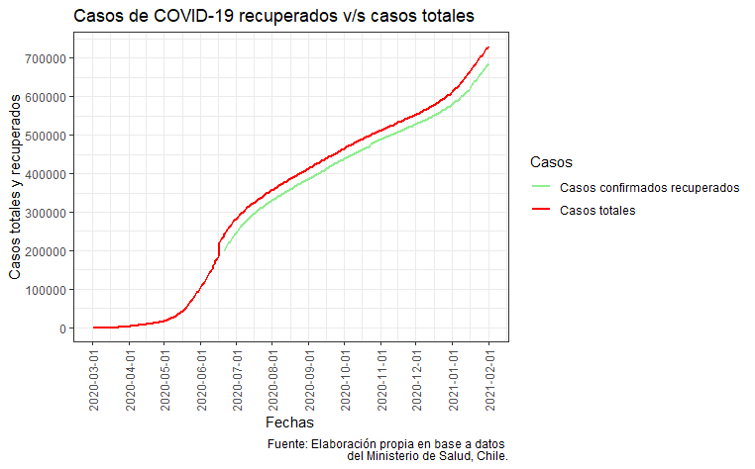

According to data from the UC Center for Longitudinal Surveys and Studies, employment problems reached 31 percent of the active labor force in July (including those who were looking for work, those who would do so if the pandemic did not interfere, and those who were covered by the Employment Protection Law implemented by the government to face the crisis). The economic crisis, as well as infection and death rates, particularly affected the most vulnerable sectors and those who work in the informal sector, including a significant proportion of recent immigrants. The government of Chile tried to balance the economic/public health dilemma by implementing a system of “dynamic quarantines,” administered at the municipal level. This system ended up worsening the contagion rate, and redistributing the economic, social and health costs of the pandemic among the poorest sectors of the city. These sectors had already been hit by the economic effects and the uncertainty generated by the social outbreak of October 2019.

**Quito**

On January 30, 2021, the Ecuadorian Ministry of Health, through their Info-graph N ° 338, registers 80,846 confirmed cases of Covid-19 in the city of Quito. This figure corresponds to a contagion rate of 2.90% of the total population, which by the end of 2020 is estimated to have climbed to 2,781,641.[1] According to the INEC population estimate, Quito is one of the most populated cities in the country with 15.89% of the total of 17,541,643 Ecuadorians estimated for 2020. In addition, Quito is the city in Ecuador with the most confirmed infections with 32.37% of the national total.[2] Moreover, the province of Pichincha, within which the city of Quito has 92.33% of the contagion cases, has a mortality rate of 2.76%. Until January 29, 2021, the provincial COE in its Weekly Bulletin indicates that the number of people who died from confirmed cases of Covid-19 amounts to a total of 1,921; while the deaths indicated as probable are 289 people and the suspected cases are 130, that is, a total of 2,340 deaths.[3]

If we classify the cases of Covid-19 infections by age, until January 30, 2021, we have: over 65 years 11.24%; between 50 and 64 years, 20.63%; from 20 to 49 years old 62.50% (the most numerous); and less than 20 years, 5.63%. In the following table and figures we can see the monthly evolution of the number of people infected with Covid-19 in the city of Quito, from the start of the pandemic in March 2020 to date.

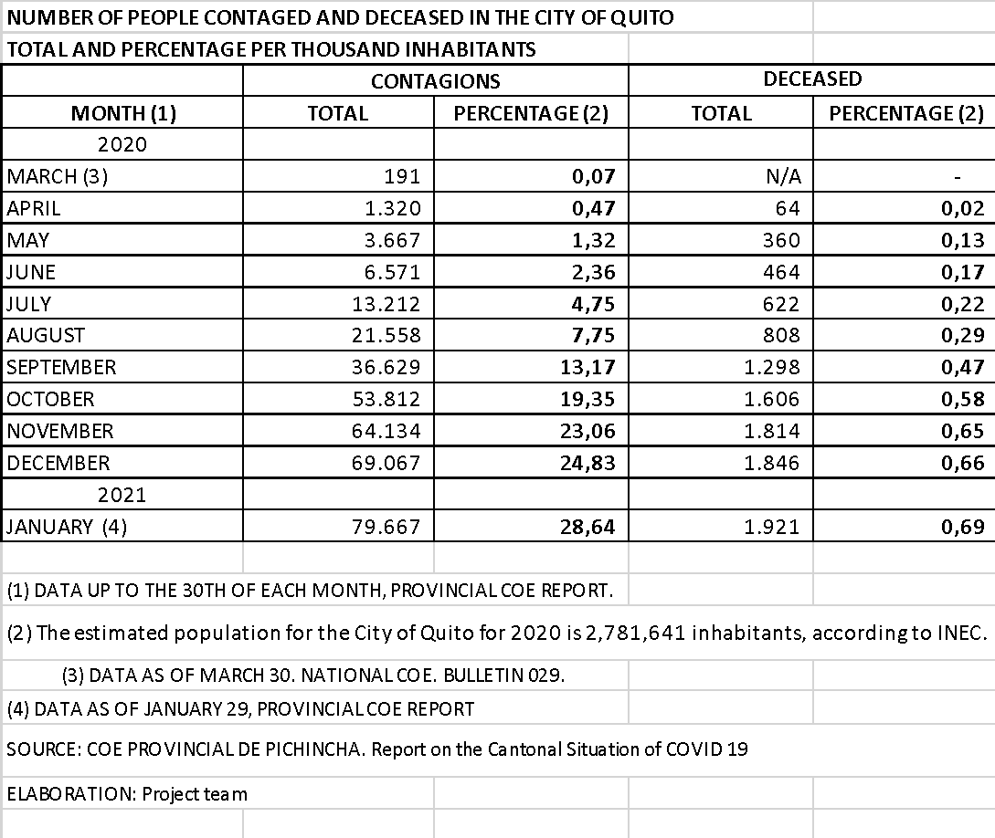

In the figures, we can see the accelerated rate of contagion and deaths in the city of Quito, mainly from the lifting of population confinement and the opening of productive activities on the first days of June. In fact, the highest peak of infections occurred in the months of September and October. On the other hand, the rebound in December 2020 and January 2021 has been related to family gatherings for the New Year's festivities and vacation holidays.

Without a doubt, Quito is the most economically affected city in Ecuador. According to the Internal Revenue Service (SRI), the city stopped selling and exporting between January and July 2020, 27% of what was obtained in the same period during 2019. This represented a loss in the amount of 11,422 million Dollars. On the other hand, the Quito Chamber of Commerce (CCQ) estimates that in June 2020 the unemployment rate in the city was 22.8%, which is, 9.5 percentage points above the national unemployment rate. Finally, tax collection in Ecuador between January and August 2020 decreased by USD 1,698 million compared to the same period in 2019. Of that value, close to USD 1,089 million are due to the contraction of the payment of taxes in Quito.

Currently, the capacity of intensive care hospital assistance is fully occupied due to the increase in daily infections. The cantonal COE and the Municipality of Quito have taken measures to limit mobility such as restrictions and calendarization in the use of vehicles.

1. INEC (2020). Projection of the Ecuadorian Population by Year, According to Cantons 2010-2020, Population projections.
2. Secretaria Nacional de Riesgos y Energencias del Ecuador (2021). Infograph N ° 338 (1/30/2021).
3. Provincial COE of Pichincha (2021). Weekly Bulletin as of 01/29/2021.